|  |  |
| --- | --- |
|  |  |

|  |
| --- |
| **Wave overtopping at dikes kernel**  Test report 22.1.1 |

|  |
| --- |
| Author(s)  Hans de Waal |

|  |
| --- |
|  |

|  |
| --- |
| **Wave overtopping at dikes kernel**  Test report 22.1.1 |

|  |  |
| --- | --- |
| Client | Rijkswaterstaat Water, Verkeer en Leefomgeving |
| Contact | de heer ir. R. Slomp |
| Reference | KPP Waterveiligheidsinstrumentarium. KPP2022 WK03: Ondersteuning |
| Keywords | Wave overtopping, wave run-up, overtopping, run-up, dikes, WBI 2017, safety assessment, software, failure mechanism |

|  |  |
| --- | --- |
| Document control | |
| Version | 0.1 |
| Date | 01-03-2022 |
| Project nr. | 11208059-000 |
| Document ID | - |
| Pages | 1 |
| Classification |  |
| Status | draft  This is a draft report, intended for discussion purposes only. No part of this report may be relied upon by either principals or third parties. |

|  |  |  |
| --- | --- | --- |
| Author(s) | | |
|  | Hans de Waal |  |
|  |  |  |

|  |  |  |  |  |
| --- | --- | --- | --- | --- |
| Doc. version | Author | Reviewer | Approver | Publish |
| 0.1 | Hans de Waal | Edwin Spee | Paul van Steeg |  |
|  |  |  |  |  |

Summary

This document describes the test results for the 22.1.1 version of the 'wave overtopping at dikes' kernel. It also contains some recommendations for further improvements on the test procedure.

Samenvatting

Dit document beschrijft de testresultaten voor de 22.1.1 versie van de rekenkern “golfoverslag bij dijken”. Het bevat ook enkele aanbevelingen voor verbeteringen van de testprocedure.

Contents

Summary 4

Samenvatting 5

1 Introduction 7

2 Test results 8

2.1 Results from TeamCity 8

2.2 Results from trends tests 11

2.2.1 Overview 11

2.2.2 Cross section 2, test series 18-19 12

2.2.3 Cross section 3, test series 1 (and 2) 13

2.2.4 Cross section 3, test series 19 13

2.2.5 Cross section 6, test series 12-17 14

2.2.6 Cross section 7 (and 8), test series 3 (and 4) 15

2.2.7 Cross section 7, test series 11 15

2.2.8 Cross section 7, test series 12 16

3 Conclusions and recommendations 17

References 18

A Figures of trends tests results 19

# Introduction

This document describes the test results for the 22.1.1 version of the 'wave overtopping at dikes' kernel. The functional design of this kernel is given in (De Waal, 2017) and the test plan is given in (De Waal, 2018).

There are no changes in the tests compared to the 19.1.1 version, and they still pass: there are no changes in the test results. The table in section 2.2.1 and the figures in Appendix A were updated anyway.

# Test results

## Results from TeamCity

The test bench runs automatically on TeamCity, a well-known continuous integration environment. It compares actual results with results from a reference run.

The overtopping project can be found here:

https://dpcbuild.deltares.nl/project.html?projectId=VtvInstrumentarium_Kernels_DikesOvertopping

**Unit tests DikesOvertopping 32-bit, version: 22.1.1.11784**

|  |  |
| --- | --- |
| **General; Test functions versionNumber, calculateQoF, calcZValue in the dll** | OK |
| **General; Test a dikeheight at one of the profile points** | OK |
| **General; Test influence roughness** | OK |
| **General; Test validation of incorrect profile and negative model factor** | OK |
| **General; Test validation of invalid roughness** | OK |
| **General; Test validation of incorrect profile and negative model factor in one call** | OK |
| **General; Test message of incorrect profile (z-value)** | OK |
| **General: Test message of invalid slope** | OK |
| **General; Test h+z2 > dikeheight** | OK |
| **General; Test error handling in case of NaN in load** | OK |
| **General; Test whether the profile is adapted correctly** | OK |
| **General; ISSUE; Test A for calculateGammaF related to issue 44** | OK |
| **General; ISSUE; Test B for calculateGammaF related to issue 44** | OK |
| **General; ISSUE; Test for issue 45** | OK |
| **Uniform Slope; Test the dll for a uniform slope (18 cases)** | OK |
| **General; ISSUE; Omkeervar** | OK |
| **General; ISSUE; two berms** | OK |
| **OmkeerVariant; inverse of overtoppingDllTest test** | OK |
| **OmkeerVariant; high discharge** | OK |
| **OmkeerVariant; expected dikeheight in profile** | OK |
| **OmkeerVariant; with berm** | OK |
| **OmkeerVariant; with berm and dikeheight just above berm** | OK |
| **OmkeerVariant; with berm and expected dikeheight just above berm** | OK |
| **OmkeerVariant; with 1:15 berm and expected dikeheight halfway berm** | OK |
| **OmkeerVariant; with a very small discharge** | OK |
| **OmkeerVariant; with water level below toe** | OK |
| **OmkeerVariant; with expected dikeheight halfway last slope segment** | OK |
| **OmkeerVariant; ISSUE; test A related to issue 34** | OK |
| **OmkeerVariant; ISSUE; test B related to issue 34** | OK |
| **OmkeerVariant; ISSUE; test C related to issue 34** | OK |
| **OmkeerVariant; ISSUE; test A related to issue 35** | OK |
| **OmkeerVariant; ISSUE; test B related to issue 35** | OK |
| **OmkeerVariant; ISSUE; test C related to issue 35** | OK |
| **OmkeerVariant; ISSUE; test A related to issue 36: wl at toe; 1:4; long dike** | OK |
| **OmkeerVariant; ISSUE; test B related to issue 36: wl at toe; 1:4; short dike** | OK |
| **OmkeerVariant; ISSUE; test A related to issue 42: berm at waterlevel** | OK |
| **OmkeerVariant; ISSUE; test B related to issue 42: resulting dikeheight at end of berm** | OK |
| **OmkeerVariant; ISSUE; test A related to issue 51** | OK |
| **OmkeerVariant; load tests** | OK |
| **OmkeerVariant; ISSUE; test A related to issue 52** | OK |
| **Java/FEWS interface; Test validation (A)** | OK |
| **Java/FEWS interface; Test validation (B)** | OK |
| **Java/FEWS interface; Test CalculateQoJ** | OK |
| **Java/FEWS interface; Test omkeerVariantJ** | OK |
| **Trends; Series of varying load with the dll in test series 1 for cross section 1** | OK |
| **Trends; Series of varying load with the dll in test series 2 for cross section 1** | OK |
| **Trends; Series of varying load with the dll in test series 3 for cross section 1** | OK |
| **Trends; Series of varying load with the dll in test series 4 for cross section 1** | OK |
| **Trends; Series of varying load with the dll in test series 5 for cross section 1** | OK |
| **Trends; Series of varying load with the dll in test series 6 for cross section 1** | OK |
| **Trends; Series of varying load with the dll in test series 7 for cross section 1** | OK |
| **Trends; Series of varying load with the dll in test series 1 for cross section 2** | OK |
| **Trends; Series of varying load with the dll in test series 2 for cross section 2** | OK |
| **Trends; Series of varying load with the dll in test series 3 for cross section 2** | OK |
| **Trends; Series of varying load with the dll in test series 4 for cross section 2** | OK |
| **Trends; Series of varying load with the dll in test series 5 for cross section 2** | OK |
| **Trends; Series of varying load with the dll in test series 6 for cross section 2** | OK |
| **Trends; Series of varying load with the dll in test series 7 for cross section 2** | OK |
| **Trends; Series of varying load with the dll in test series 1 for cross section 3** | OK |
| **Trends; Series of varying load with the dll in test series 2 for cross section 3** | OK |
| **Trends; Series of varying load with the dll in test series 3 for cross section 3** | OK |
| **Trends; Series of varying load with the dll in test series 4 for cross section 3** | OK |
| **Trends; Series of varying load with the dll in test series 5 for cross section 3** | OK |
| **Trends; Series of varying load with the dll in test series 6 for cross section 3** | OK |
| **Trends; Series of varying load with the dll in test series 7 for cross section 3** | OK |
| **Trends; Series of varying load with the dll in test series 1 for cross section 4** | OK |
| **Trends; Series of varying load with the dll in test series 2 for cross section 4** | OK |
| **Trends; Series of varying load with the dll in test series 3 for cross section 4** | OK |
| **Trends; Series of varying load with the dll in test series 4 for cross section 4** | OK |
| **Trends; Series of varying load with the dll in test series 5 for cross section 4** | OK |
| **Trends; Series of varying load with the dll in test series 6 for cross section 4** | OK |
| **Trends; Series of varying load with the dll in test series 7 for cross section 4** | OK |
| **Trends; Series of varying load with the dll in test series 1 for cross section 5** | OK |
| **Trends; Series of varying load with the dll in test series 2 for cross section 5** | OK |
| **Trends; Series of varying load with the dll in test series 3 for cross section 5** | OK |
| **Trends; Series of varying load with the dll in test series 4 for cross section 5** | OK |
| **Trends; Series of varying load with the dll in test series 5 for cross section 5** | OK |
| **Trends; Series of varying load with the dll in test series 6 for cross section 5** | OK |
| **Trends; Series of varying load with the dll in test series 7 for cross section 5** | OK |
| **Trends; Series of varying load with the dll in test series 1 for cross section 6** | OK |
| **Trends; Series of varying load with the dll in test series 2 for cross section 6** | OK |
| **Trends; Series of varying load with the dll in test series 3 for cross section 6** | OK |
| **Trends; Series of varying load with the dll in test series 4 for cross section 6** | OK |
| **Trends; Series of varying load with the dll in test series 5 for cross section 6** | OK |
| **Trends; Series of varying load with the dll in test series 6 for cross section 6** | OK |
| **Trends; Series of varying load with the dll in test series 7 for cross section 6** | OK |
| **Trends; Series of varying load with the dll in test series 1 for cross section 7** | OK |
| **Trends; Series of varying load with the dll in test series 2 for cross section 7** | OK |
| **Trends; Series of varying load with the dll in test series 3 for cross section 7** | OK |
| **Trends; Series of varying load with the dll in test series 4 for cross section 7** | OK |
| **Trends; Series of varying load with the dll in test series 5 for cross section 7** | OK |
| **Trends; Series of varying load with the dll in test series 6 for cross section 7** | OK |
| **Trends; Series of varying load with the dll in test series 7 for cross section 7** | OK |
| **Trends; Series of varying load with the dll in test series 1 for cross section 8** | OK |
| **Trends; Series of varying load with the dll in test series 2 for cross section 8** | OK |
| **Trends; Series of varying load with the dll in test series 3 for cross section 8** | OK |
| **Trends; Series of varying load with the dll in test series 4 for cross section 8** | OK |
| **Trends; Series of varying load with the dll in test series 5 for cross section 8** | OK |
| **Trends; Series of varying load with the dll in test series 6 for cross section 8** | OK |
| **Trends; Series of varying load with the dll in test series 7 for cross section 8** | OK |
| **Trends; Series (A) of varying geometry with the dll in test series 8 for cross section 1** | OK |
| **Trends; Series (A) of varying geometry with the dll in test series 9 for cross section 1** | OK |
| **Trends; Series (A) of varying geometry with the dll in test series 8 for cross section 2** | OK |
| **Trends; Series (A) of varying geometry with the dll in test series 9 for cross section 2** | OK |
| **Trends; Series (A) of varying geometry with the dll in test series 10 for cross section 2** | OK |
| **Trends; Series (A) of varying geometry with the dll in test series 11 for cross section 2** | OK |
| **Trends; Series (A) of varying geometry with the dll in test series 12 for cross section 2** | OK |
| **Trends; Series (A) of varying geometry with the dll in test series 13 for cross section 2** | OK |
| **Trends; Series (A) of varying geometry with the dll in test series 8 for cross section 3** | OK |
| **Trends; Series (A) of varying geometry with the dll in test series 9 for cross section 3** | OK |
| **Trends; Series (A) of varying geometry with the dll in test series 10 for cross section 3** | OK |
| **Trends; Series (A) of varying geometry with the dll in test series 11 for cross section 3** | OK |
| **Trends; Series (A) of varying geometry with the dll in test series 12 for cross section 3** | OK |
| **Trends; Series (A) of varying geometry with the dll in test series 13 for cross section 3** | OK |
| **Trends; Series (A) of varying geometry with the dll in test series 8 for cross section 4** | OK |
| **Trends; Series (A) of varying geometry with the dll in test series 9 for cross section 4** | OK |
| **Trends; Series (A) of varying geometry with the dll in test series 10 for cross section 4** | OK |
| **Trends; Series (A) of varying geometry with the dll in test series 11 for cross section 4** | OK |
| **Trends; Series (A) of varying geometry with the dll in test series 12 for cross section 4** | OK |
| **Trends; Series (A) of varying geometry with the dll in test series 13 for cross section 4** | OK |
| **Trends; Series (A) of varying geometry with the dll in test series 8 for cross section 5** | OK |
| **Trends; Series (A) of varying geometry with the dll in test series 9 for cross section 5** | OK |
| **Trends; Series (A) of varying geometry with the dll in test series 10 for cross section 5** | OK |
| **Trends; Series (A) of varying geometry with the dll in test series 11 for cross section 5** | OK |
| **Trends; Series (A) of varying geometry with the dll in test series 8 for cross section 6** | OK |
| **Trends; Series (A) of varying geometry with the dll in test series 9 for cross section 6** | OK |
| **Trends; Series (A) of varying geometry with the dll in test series 10 for cross section 6** | OK |
| **Trends; Series (A) of varying geometry with the dll in test series 11 for cross section 6** | OK |
| **Trends; Series (A) of varying geometry with the dll in test series 8 for cross section 7** | OK |
| **Trends; Series (A) of varying geometry with the dll in test series 9 for cross section 7** | OK |
| **Trends; Series (A) of varying geometry with the dll in test series 8 for cross section 8** | OK |
| **Trends; Series (A) of varying geometry with the dll in test series 9 for cross section 8** | OK |
| **Trends; Series (B) of varying geometry with the dll in test series 8 for cross section 4** | OK |
| **Trends; Series (B) of varying geometry with the dll in test series 9 for cross section 4** | OK |
| **Trends; Series (B) of varying geometry with the dll in test series 8 for cross section 5** | OK |
| **Trends; Series (B) of varying geometry with the dll in test series 9 for cross section 5** | OK |
| **Trends; Series (B) of varying geometry with the dll in test series 8 for cross section 6** | OK |
| **Trends; Series (B) of varying geometry with the dll in test series 9 for cross section 6** | OK |
| **Trends; Series of varying roughness with the dll in test series 10 for cross section 1** | OK |
| **Trends; Series of varying roughness with the dll in test series 11 for cross section 1** | OK |
| **Trends; Series of varying roughness with the dll in test series 14 for cross section 2** | OK |
| **Trends; Series of varying roughness with the dll in test series 15 for cross section 2** | OK |
| **Trends; Series of varying roughness with the dll in test series 16 for cross section 2** | OK |
| **Trends; Series of varying roughness with the dll in test series 17 for cross section 2** | OK |
| **Trends; Series of varying roughness with the dll in test series 18 for cross section 2** | OK |
| **Trends; Series of varying roughness with the dll in test series 19 for cross section 2** | OK |
| **Trends; Series of varying roughness with the dll in test series 14 for cross section 3** | OK |
| **Trends; Series of varying roughness with the dll in test series 15 for cross section 3** | OK |
| **Trends; Series of varying roughness with the dll in test series 16 for cross section 3** | OK |
| **Trends; Series of varying roughness with the dll in test series 17 for cross section 3** | OK |
| **Trends; Series of varying roughness with the dll in test series 18 for cross section 3** | OK |
| **Trends; Series of varying roughness with the dll in test series 19 for cross section 3** | OK |
| **Trends; Series of varying roughness with the dll in test series 14 for cross section 4** | OK |
| **Trends; Series of varying roughness with the dll in test series 15 for cross section 4** | OK |
| **Trends; Series of varying roughness with the dll in test series 16 for cross section 4** | OK |
| **Trends; Series of varying roughness with the dll in test series 17 for cross section 4** | OK |
| **Trends; Series of varying roughness with the dll in test series 12 for cross section 5** | OK |
| **Trends; Series of varying roughness with the dll in test series 13 for cross section 5** | OK |
| **Trends; Series of varying roughness with the dll in test series 14 for cross section 5** | OK |
| **Trends; Series of varying roughness with the dll in test series 15 for cross section 5** | OK |
| **Trends; Series of varying roughness with the dll in test series 16 for cross section 5** | OK |
| **Trends; Series of varying roughness with the dll in test series 17 for cross section 5** | OK |
| **Trends; Series of varying roughness with the dll in test series 18 for cross section 5** | OK |
| **Trends; Series of varying roughness with the dll in test series 19 for cross section 5** | OK |
| **Trends; Series of varying roughness with the dll in test series 12 for cross section 6** | OK |
| **Trends; Series of varying roughness with the dll in test series 13 for cross section 6** | OK |
| **Trends; Series of varying roughness with the dll in test series 14 for cross section 6** | OK |
| **Trends; Series of varying roughness with the dll in test series 15 for cross section 6** | OK |
| **Trends; Series of varying roughness with the dll in test series 16 for cross section 6** | OK |
| **Trends; Series of varying roughness with the dll in test series 17 for cross section 6** | OK |
| **Trends; Series of varying roughness with the dll in test series 18 for cross section 6** | OK |
| **Trends; Series of varying roughness with the dll in test series 19 for cross section 6** | OK |
| **Trends; Series of varying roughness with the dll in test series 10 for cross section 7** | OK |
| **Trends; Series of varying roughness with the dll in test series 11 for cross section 7** | OK |
| **Trends; Series of varying roughness with the dll in test series 12 for cross section 7** | OK |
| **Trends; Series of varying roughness with the dll in test series 13 for cross section 7** | OK |
| **Trends; Series of varying roughness with the dll in test series 10 for cross section 8** | OK |
| **Trends; Series of varying roughness with the dll in test series 11 for cross section 8** | OK |
| **Trends; Series of varying roughness with the dll in test series 12 for cross section 8** | OK |
| **Trends; Series of varying roughness with the dll in test series 13 for cross section 8** | OK |
| **Unit tests; Test CalculateGammaF (tiny waves)** | OK |
| **Unit tests; Test CalculateGammaF (normal waves)** | OK |

**Summary:**

|  |  |
| --- | --- |
| Number of tests run: | 182 |
| Number of tests ignored: | 0 |
| Number of tests failed: | 0 |
| Number of failed assertions: | 0 |
| Number of runs needed to complete the tests: | 1 |

We conclude that all tests succeeded.

## Results from trends tests

### Overview

All trends test series fulfil the expectations, with exceptions enumerated in Table 2.1.

|  |  |  |  |  |  |
| --- | --- | --- | --- | --- | --- |
| FigA | Section | Series | Unexpected feature | Location along  x-axis | Explained in |
| 1.5 | 1 | 5 | slight increase (jump) in discharge | 0.02 | - |
| 2.18 | 2 | 18 | constant discharge | all range | 2.2.2 |
| 2.19 | 2 | 19 | constant run-up, discharge and HBN | all range | 2.2.2 |
| 3.1 | 3 | 1 | slight decrease in discharge and HBN | 0.1 - 0.2 | 2.2.3 |
| 3.2 | 3 | 2 | slight decrease in discharge and HBN | 1.6 - 1.8 | 2.2.3 |
| 3.15 | 3 | 15 | slight decrease in discharge and HBN | 0.52 - 0.54 | - |
| 3.19 | 3 | 19 | slight decrease in discharge and HBN | 0.50 - 0.65 | 2.2.4 |
| 4.13 | 4 | 11 | irregular trend for HBN2 | 5.5 - 6.0 | - |
| 4.17 | 4 | 15 | decrease in HBN | 0.50 - 0.80 | - |
| 4.19 | 4 | 17 | drop in run-up | 0.51 - 0.52 | - |
| 4.19 | 4 | 17 | jump in discharge and HBN | 0.65 - 0.90 | - |
| 4.19 | 4 | 17 | irregular trend for HBN2 | 5.5 - 6.0 | - |
| 5.13 | 5 | 11 | irregular trend for HBN2 | 4.0 - 7.5 | - |
| 6.2 | 6 | 2 | slight decrease in discharge | 1.0 - 1.5 | - |
| 6.14 | 6 | 12 | constant discharge and HBN | all range | 2.2.5 |
| 6.15 | 6 | 13 | constant run-up, discharge and HBN | all range | 2.2.5 |
| 6.16 | 6 | 14 | constant discharge and HBN | all range | 2.2.5 |
| 6.17 | 6 | 15 | constant run-up, discharge and HBN | all range | 2.2.5 |
| 6.18 | 6 | 16 | constant discharge and HBN | all range | 2.2.5 |
| 6.19 | 6 | 17 | constant run-up, discharge and HBN | all range | 2.2.5 |
| 7.1 | 7 | 1 | minor jump in run-up, discharge and HBN | 2 | - |
| 7.3 | 7 | 3 | minor jump in run-up, discharge and HBN | 2 | 2.2.6 |
| 7.4 | 7 | 4 | minor jump in run-up, discharge and HBN | 2.4 | 2.2.6 |
| 7.7 | 7 | 7 | minor drop in run-up, discharge and HBN | 80 - 81 | - |
| 7.10 | 7 | 10 | slight decrease in run-up | 0.53 - 0.55 | - |
| 7.11 | 7 | 11 | decrease (drop) in discharge and HBN | 0.66 - 0.90 | 2.2.7 |
| 7.12 | 7 | 12 | minor jump in run-up, drop in HBN | 0.67 - 0.68 | 2.2.8 |
| 7.13 | 7 | 13 | jump in discharge and HBN | 0.79 - 0.95 | - |
| 8.3 | 8 | 3 | minor jump in run-up, discharge and HBN | 2.25 | 2.2.6 |
| 8.4 | 8 | 4 | minor jump in run-up, discharge and HBN | 2.7 | 2.2.6 |
| 8.9 | 8 | 9 | irregular trend for HBN2 | 5.5 - 7.0 | - |

Table 2.1 Test series where trends in computational results do not meet the expectations.

All of these unexpected trends were already observed earlier and some of them were already explained in earlier versions of the test report. These explanations are repeated below.

### Cross section 2, test series 18-19

The wave run-up and/or overtopping discharge in these test series are constant for varying roughness. For test series 18, with wave direction 0º (w.r.t. the dike normal) only the overtopping discharge is constant. For test series 19, with wave direction 85º (w.r.t. the dike normal) both the wave run-up and overtopping discharge are constant.

The explanation for test series 19 is as follows: in the calculation of the influence factor for roughness only the roughness of the lower segment is used (due the combination of the still water level and the wave run-up itself), and since the roughness of this segment is not varied in this test series, the results are the same for all roughness coefficients.

For test series 18 a small part of the upper segment is used in the assessment of the roughness coefficient. The increase in roughness parameter leads to a small increase in run-up level. A closer look at the trend in the ASCII output reveals that also the overtopping discharge shows a small increase with increasing roughness parameter (not noticeable in the graphical output). Therefore, also the trend in test series 18 agrees with the expectation.

### Cross section 3, test series 1 (and 2)

Figure 2.1 shows the dimensionless overtopping discharge for both the breaking and non-breaking waves, for cross section 3, with varying water level (test series 1). The resulting overtopping discharge equals the minimum of these two values (multiplied by a factor depending on the wave height). For lower water levels this result is based on the overtopping discharge for non-breaking waves (Qn), but for higher water levels the result is based on the overtopping discharge for breaking waves (Qb). The latter does not always increase with increasing water levels, since it depends on the representative slope angle. For cross section 3 the representative slope angle decreases with increasing water level, because the lower segment has a steeper slope than the upper segment.

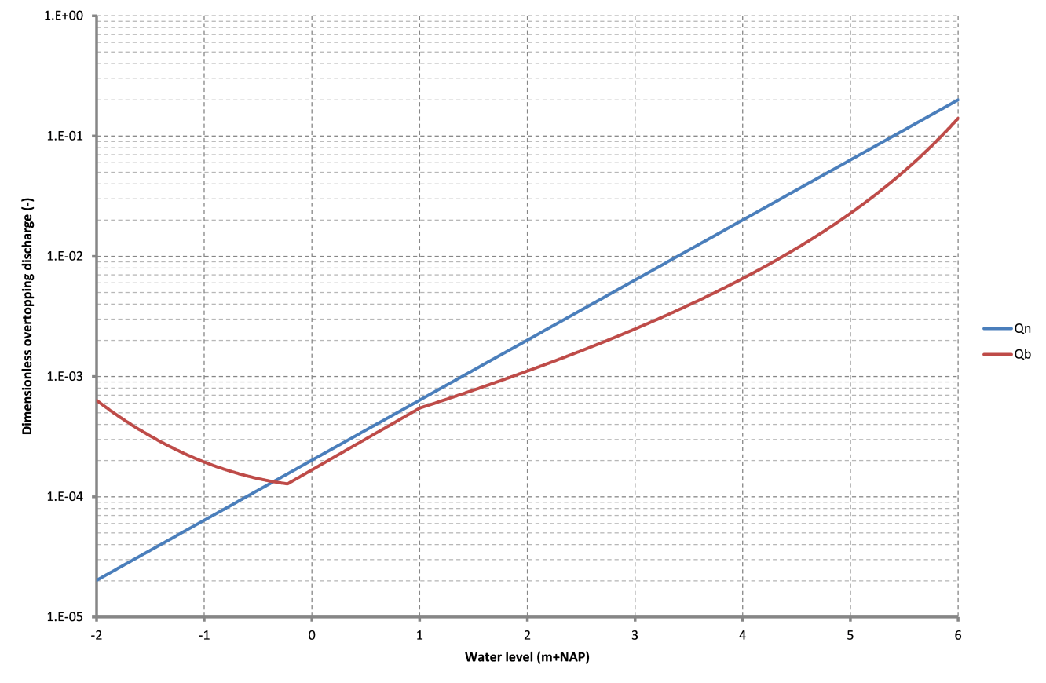

Figure 2.1 Dimensionless overtopping discharge for breaking (Qb) and non-breaking (Qn) waves, cross section 3, test series 1, based on old test data

### Cross section 3, test series 19

For this test series the overtopping discharge increases when the roughness coefficient decreases (for part of the test series). In this case, the overtopping discharge is completely determined by the overtopping discharge for breaking waves. When all other parameters are fixed, this discharge decreases when the roughness coefficient decreases. In this case however, also the breaker parameter changes and increases with the decreasing roughness coefficient, see Figure 2.2. For small roughness coefficients, the increasing breaker parameter has a larger effect than the decreasing value of the roughness coefficient itself, which leads to larger overtopping discharges. The increasing breaker parameter is a side-effect of the decreasing roughness coefficient, since the wave run-up decreases and therefore the representative slope angle is more and more influenced by the steeper lower segment from cross section 3.

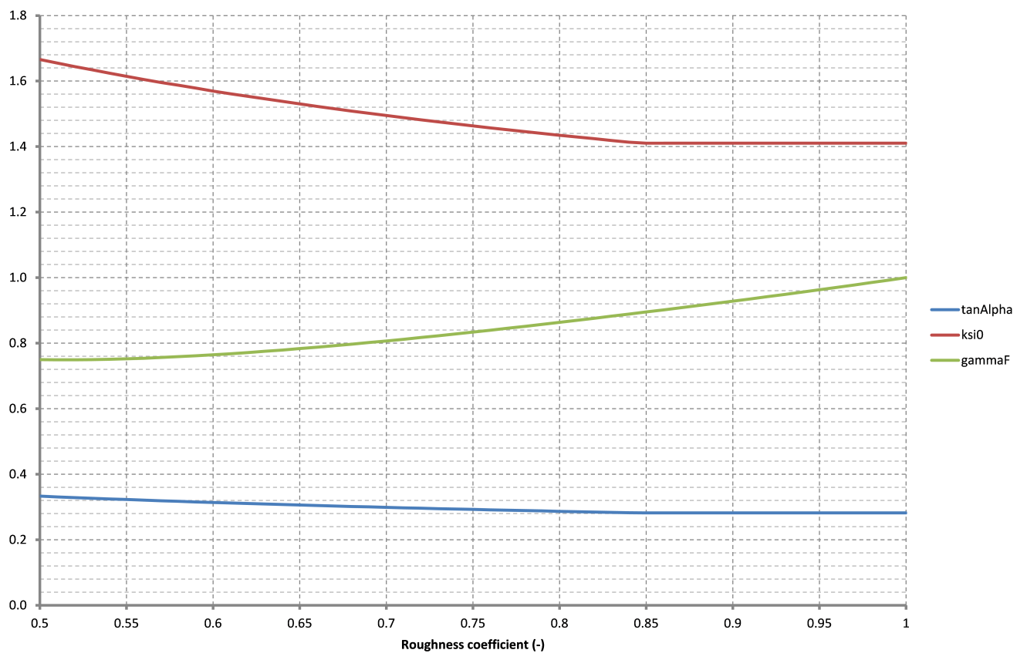

Figure 2.2 Representative slope (tanAlpha), breaker parameter (ksi0) and influence factor roughness (gammaF), cross section 3, test series 19, based on old test data

### Cross section 6, test series 12-17

The wave run-up and/or overtopping discharge in these test series are constant for varying roughness. For the test series 12, 14, and 16, with wave direction 0º (w.r.t. the dike normal) only the overtopping discharge is constant. For the test series 13, 15 and 17, with wave direction 85º (w.r.t. the dike normal) both the wave run-up and overtopping discharge are constant.

In the latter cases, the explanation is as follows: in the calculation of the influence factor for roughness only the roughness of the upper segment is used (due the combination of the still water level and the wave run-up itself), and since the roughness of this segment is not varied in the test series, the results are the same for all roughness coefficients.

For the test series 12, 14 and 16 the situation is more complex: the wave run-up changes, but the overtopping discharge is constant for varying roughness coefficients. This most likely has to do with the iteration procedure in the calculation of the wave run-up: probably z2% shows flop behaviour between two values.

For the calculation of the overtopping discharge, the influence factor for roughness is based on the final value of the wave run-up. Thereby only the upper segment is used in the calculation of the influence factor for roughness, and since the roughness of this segment is not varied in the test series, the overtopping discharge is the same for all roughness coefficients.

The final value of the wave run-up is assessed using the influence factor for roughness that was based on the preceding value of the wave run-up. As a consequence of flip flop behaviour, the run-up values from two succeeding iteration steps can differ significantly, leading to different values for the influence factor for roughness. Most likely the run-up value in the last but one iteration step was larger, so that in the final step the varying roughness of segment (1 and/or) 2 and/or 3 was taken into account. Some further analysis is recommended in order to confirm this explanation.

### Cross section 7 (and 8), test series 3 (and 4)

The test series for cross section 7 and cross section 8 show a remarkable jump in the run-up level and overtopping discharge when the wave height increases (test series 3 and 4). This jump occurs for wave height (Hm0) equal to 2 m, and is a direct consequence of a jump in the reduction factor for berms, as shown in Figure 2.3. The calculation of the reduction factor for berms uses the influence width of each berm, which (for each berm separately) is defined as the horizontal distance between cross section point at the berm height minus one wave height and the berm height plus one wave height. For the berms in cross section 7 there is a jump in the influence width of each berm at Hm0 = 2 m, because that is exactly the point at which the width of the other berm is added to the influence width. So, in short: the jump in run-up level occurs at a wave height of 2 m, since that is exactly the vertical distance between the two berms in this cross section.

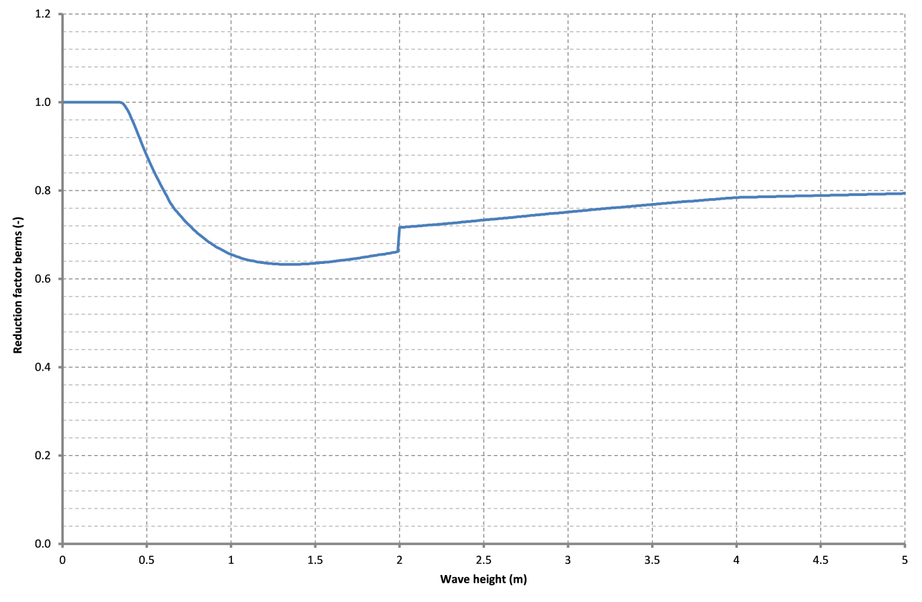

Figure 2.3 Reduction factor berms, cross section 7, test series 3, based on old test data

### Cross section 7, test series 11

For cross section 7, test series 11 there is a remarkable jump in the overtopping discharge from roughness coefficient 0.52 to roughness coefficient 0.53. For this test series the roughness coefficient in question is the roughness coefficient of the berms.

Further analysis shows that the same jump occurs in the influence factor for roughness (see Figure A.3.4). This is due to the fact that in for roughness coefficient 0.52 the wave run-up equals a little less than 2 m and therefore the influence factor for roughness is calculated based on the cross section between about 2.5 m+NAP and a little less than 4 m+NAP. For roughness coefficient 0.53 the wave run up equals a little more than 2 m and therefore the influence factor for roughness is calculated based on the cross section between about 2.5 m+NAP and a little more than 4 m+NAP. In the latter case the roughness coefficient on the second berm (at exactly 4 m+NAP) is also taken into account, in the first case not. The jump occurs because the berms in this cross section are horizontal, so the roughness on the berm is immediately taken into account for the complete berm width. This is exactly the reason why horizontal berms won’t be permitted in a real application of the overtopping module, but only for test purposes.

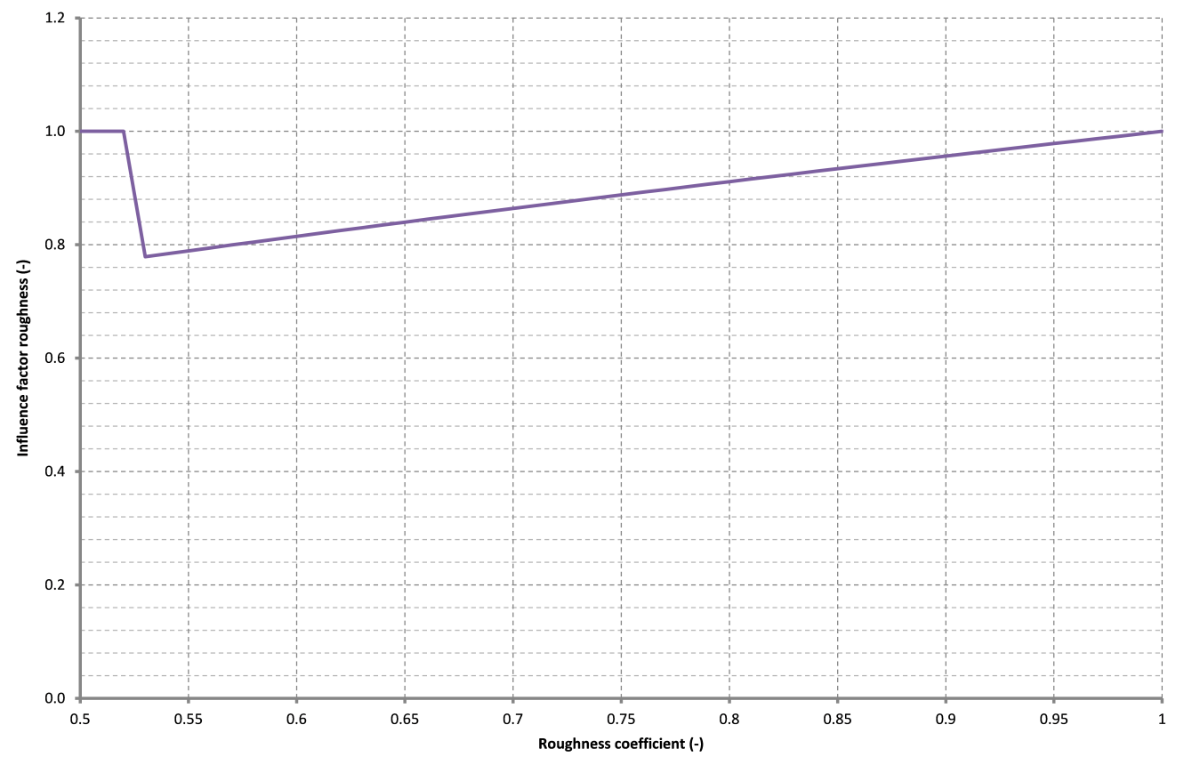

Figure 2.4 Influence factor roughness, cross section 7, test series 11, based on old test data

### Cross section 7, test series 12

For this test series a minor jump in the overtopping discharge occurs due to a larger jump in the wave run-up. The latter occurs because at this point the roughness coefficient of the lower berm is taken into account in the calculation of the influence factor for roughness. In this test series the roughness coefficient of the berms is 1 and the roughness coefficient of the other segments is varied. Therefore, the influence factor for the roughness becomes much closer to 1 when the roughness of the lower berm segment is taken into account, and as a result of that the wave run-up takes a higher value.

# Conclusions and recommendations

This document describes the test results for the overtopping at dikes kernel. The test procedure consists of several clusters of tests, as pointed out in the test plan (De Waal, 2018).

There are no changes in the tests compared to the 19.1.1 version, and they still pass: there are no changes in the test results. However, as already mentioned in the test plan, the reference results for the trend tests require some further attention.

In most trend test series the computed wave run-up, overtopping discharge and required crest level followed expected behaviour.

For most trend tests showing unexpected behaviour, further analysis showed plausible explanations of the results and that they are indeed correct. It is recommended to analyse the still remaining trend tests showing unexpected behaviour.

References

Waal, J.P. de, 2017. Wave overtopping at dikes kernel. Functional design. Deltares report, October 2017.

Waal, J.P. de, 2018. Wave overtopping at dikes kernel. Test Plan. Deltares report, December 2018.

##### Figures of trends tests results

In the figures the following notation is used:

HBN4 (m+NAP) = the required crest level for critical overtopping discharge 10-4 (m3/m/s)

HBN3 (m+NAP) = the required crest level for critical overtopping discharge 10-3 (m3/m/s)

HBN2 (m+NAP) = the required crest level for critical overtopping discharge 10-2 (m3/m/s)

